“How to Lead Culture Change in the Church”
Dr. Andrew Hebert
Paramount Baptist Church, Amarillo, Texas

I. WHAT IS CHURCH CULTURE?

Peter Drucker: “Culture eats strategy for breakfast.”

Edgar Schein: “artifacts, espoused beliefs and values, and basic underlying assumptions.”

Aubrey Malphurs adapted this definition: the make-up of a church’s culture included a church’s ____________, , and .

A church’s behavior includes “all that you would see, hear, and feel as you first encounter the congregation” (Malphurs).

A church’s values are the beliefs that the church actually live out.

A church’s beliefs: “a belief is a conviction or opinion that a person holds to be true about the church and its world as based on limited proof” (Malphurs).

II. HOW CAN YOU CHANGE OR SHAPE CHURCH CULTURE?

A. The Power of the ____________________

Sermons in Acts

Fall under three categories: missionary sermons, apologetic sermons, and paraenetic (instruction) sermons. Paraenetic sermons are “preached to believers for purposes of encouragement, edification, and/or instruction” (Wells/Luter).
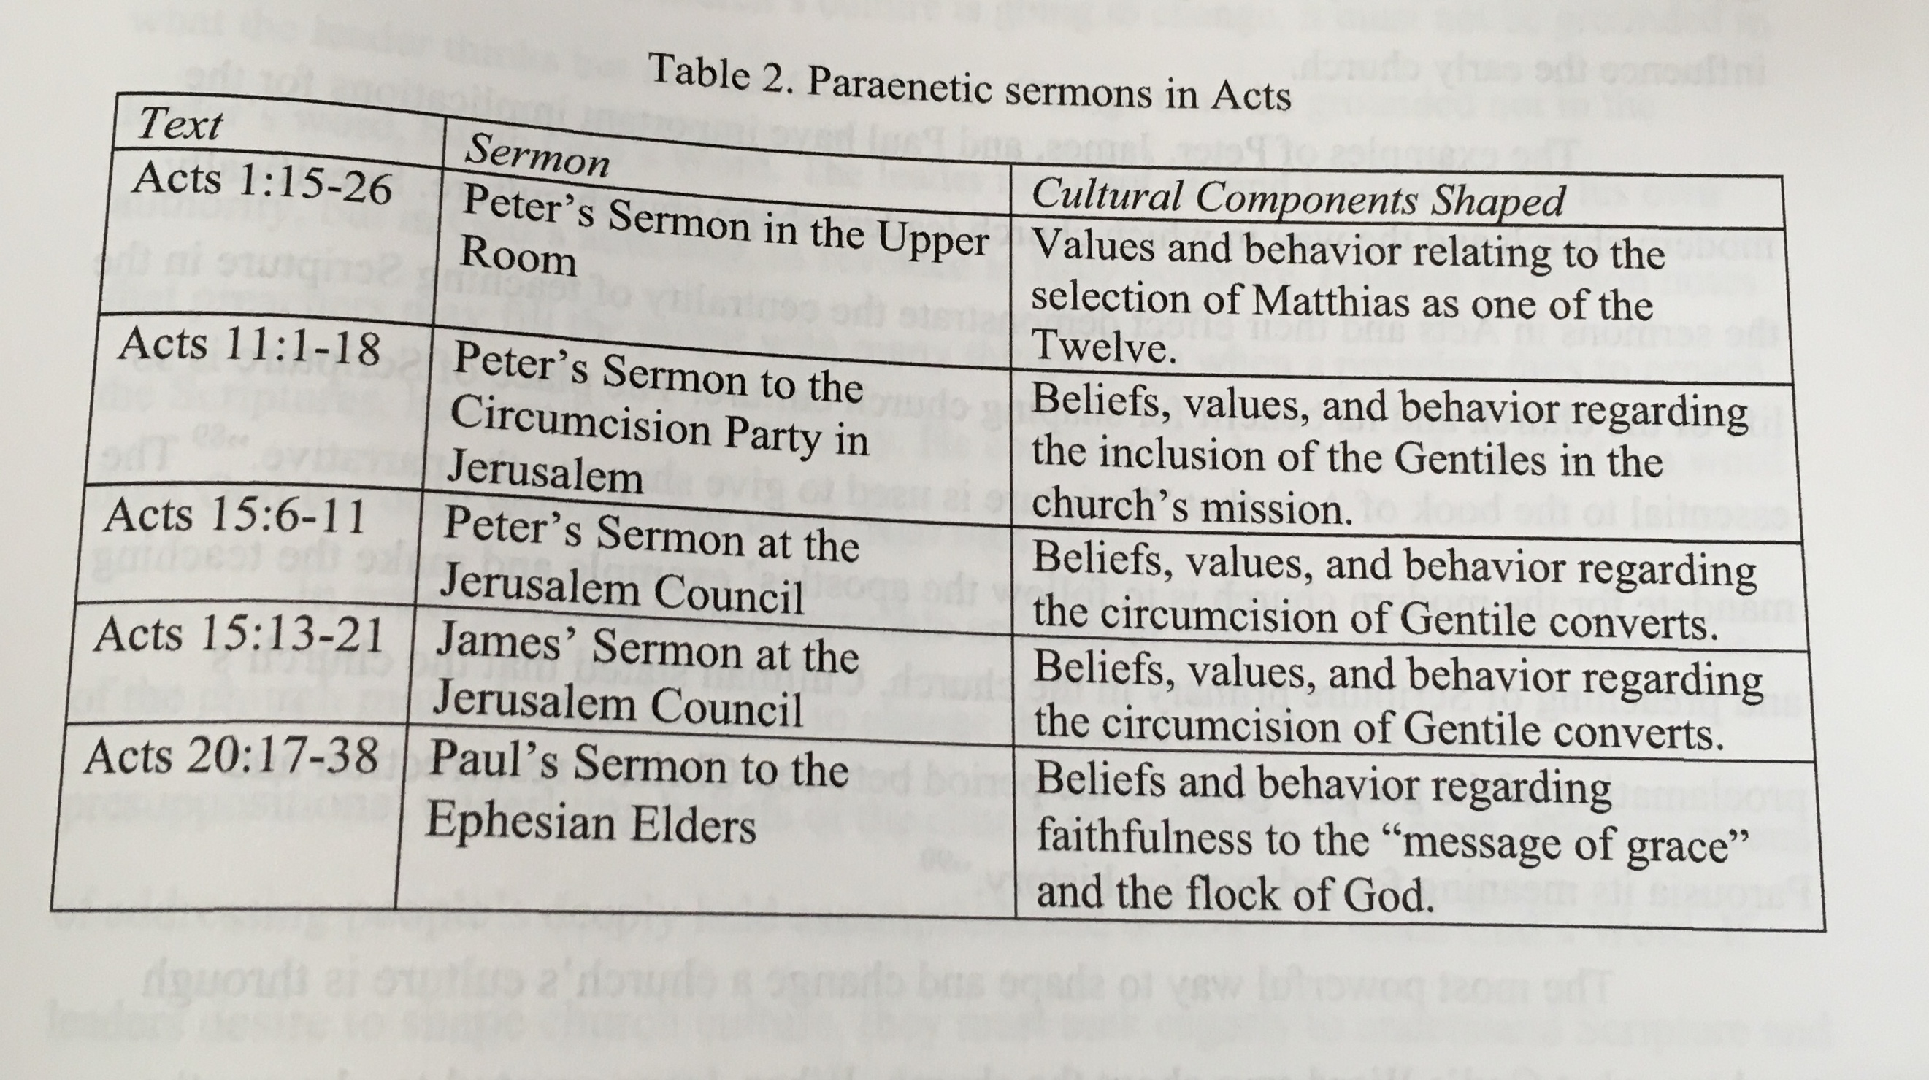

Albert Mohler: “The most effective leaders are unstoppable teachers. They teach by word, by example, and sheer force of passion. They transform their corporations, institutions, and congregations into learning organizations . . . To lead with conviction is to seize the role of the teacher with energy, determination, and even excitement.”

B. The Power of _________________

1. Leaders shape culture through .

Meals in Luke:

John Koenig: “eating and drinking” is the central motif in Luke.

Robert Karris: “In Luke’s Gospel, Jesus is either going to a meal, at a meal, or coming from a meal.”

Gordon Smith: “Meals were a central way in which Jesus portrayed the values and vision of the covenant and the meaning of the rule of God.”

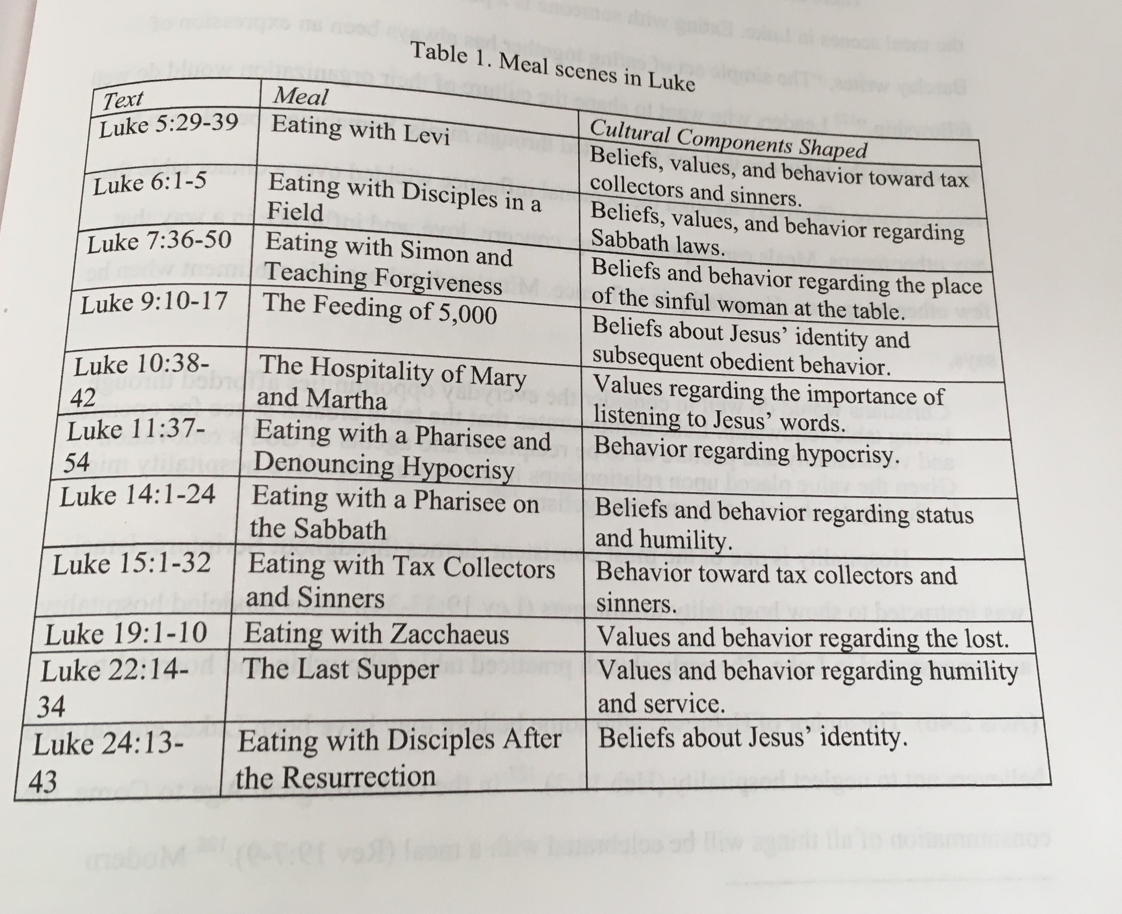

2. Leaders .

3. Leaders shape culture through .

4. Leaders shape culture by .

5. Leaders shape culture by .

6. Leaders shape culture through .

C. The Power of Community

Key stakeholders: those who hold influence over others in the organization.

III. PRACTICAL APPLICATION

A pastor must be “hospitable, an able teacher” (1 Tim 3:2).

Preach the Word

1. The leader should teach members on a one-on-one basis through personal discipleship.

2. Teaching should occur in the context of small groups.

3. Teaching Scripture should occur in the pulpit ministry of the pastor

Eat with the People

1. On a regular basis a leader should meet with members for coffee or meals during the week.

2. The leader should host people for meals in his home.

3. The leader should provide opportunities for table fellowship within the life and organization of the church.

SUGGESTED RESOURCES:

Look Before You Lead, Aubrey Malphurs
Leading Congregational Change, Herrington, Bonem, and Furr
The Heart of Change, John Kotter
Organizational Culture and Leadership, Edgar Schein

