- There’s a lot going on behind pulpits in America that is NOT Gospel Preaching.
- There are a lot of people (men and women) who are watering down the Gospel, preaching a feel-good message.
- What is real, Biblical Gospel Preaching?
- How do we know it when we hear it?

- On the Day of Pentecost, Peter preached the first Gospel Sermon.
- God used that sermon so much so that at the end of the day, 3,000 new converts had been added to the Church at Jerusalem.
- Around 3,000 people got saved and baptized!
- What did Peter say?
- What was Peter’s preaching like?
- Let’s look at Acts 2:14f and let’s see what the Bible says about…

“Gospel Preaching”
NAU Acts 2:14-41

Gospel Preaching must be Prophetically Declared (14).
  - Expl.

But Peter, taking his stand with the eleven, raised his voice and declared to them: "Men of Judea and all you who live in Jerusalem, let this be known to you and give heed to my words.
    - Gospel preaching requires a Gospel preacher.
    - The Apostle Peter was a Gospel preacher.
    - He was called of God to preach/teach the Word of God.
    - He had denied Jesus three times.

- But he repented and Jesus forgave Him.
- Now we see Peter, filled with the Holy Spirit!
- Instead of denying Jesus, he was “standing” for Jesus.
- And when he stood up for Jesus on the Day of Pentecost, the other 11 apostles stood up also – (that’s the way it works!)
- Peter had been their leader when Jesus was on earth.
- Now he was their leader after Jesus ascended to heaven.
- When Peter STOOD up, he SPOKE up.

The Bible says, “Peter, taking his stand with the eleven, raised his voice and declared to them!”
- When Peter denied that he even knew Jesus, the Bible says in NAU Matthew 26:74 - Then he began to curse and swear, "I do not know the man!"
- But now on the Day of Pentecost, Jesus, the resurrected Lord Jesus and the indwelling Holy Spirit had changed everything!
- Peter no longer said, “I don’t know Jesus!”
- Instead, he was saying, “I do know Jesus and you should know Him too!”
- The one-time coward had become a prophet.
- Peter became a man that spoke prophetically!

Illus.

- In Power through Prayer, E.M. Bounds’ classic book on prayer, he said, “The Church is looking for better methods; God is looking for better men.”
- Bounds knew that Gospel Preaching must be Prophetically Declared by a man of God!

Appl.

- God is looking for men and women, boys and girls to proclaim the truth of the Gospel.
- He’s looking for Godly men to preach the word as Biblical, Gospel-preaching, Christ-honoring pastors!
- He’s looking for women to teach other women that Jesus is the answer to the problems of life and the perils of eternity.
- He’s looking for students who will “stand up and declare”

that…

  - God loves everyone
  - All people are sinners, therefore they are lost
  - All people are sinners
  - All sinners without Jesus are lost and headed for hell
  - Jesus came to save us from our lostness
  - Jesus was born of a virgin – free from a sinful nature
  - Jesus was tempted to sin but never committed any sin
  - Jesus, the sinless Son of God, died for the sins of all
  - Jesus was buried to prove that He was dead.
  - Jesus He rose bodily, victoriously, eternally from the grave
  - Jesus now offers salvation to all people
  - Whosoever will repent of their sin & believe in Jesus will be forgiven and receive the gift of eternal life!

- The entire world needs to hear that message!
- That is the Gospel (good news) of Jesus Christ!
- It’s the power of God unto salvation (Rom. 1:16).
- Woe to any Christian that won’t share the Gospel!
- The Gospel is waiting to be shared – will you share it?

unless they believe in him? And how can they believe in him if they have never heard about him? And how can they hear about him unless someone tells them?”
- On the Day of Pentecost, God used Peter to speak the Gospel prophetically.

- Will you let the Lord use you to be His proclaimer of the sacred Gospel of Jesus Christ?

Gospel Preaching must be Prophetically Declared!

- Gospel Preaching is Scripturally Based.
  - Expl.

- Peter based his Pentecostal sermon on the OT Scripture.
- He used three OT texts to show that what happened in Jesus’ ministry and on the Day of Pentecost was rooted in OT Scripture.
- When Peter preached, he preached from the Bible.

- First of all, in Acts 2:15-21 Peter quoted Joel 2:28-32:
  - In Acts 2:13, some people who heard the disciples speaking in tongues accused them of being drunk.
  - Peter debunked those groundless accusations….

15 "For these men are not drunk, as you suppose, for it is
only the third hour of the day;

  - “The 3rd hr. of the day” was 9 am.
  - Jews didn’t eat/drink at a meal before 9 am, because 9 am was the first of three daily calls to prayer.
  - Also, this was a particularly significant Jewish Holy Day – the day of Pentecost.
  - It was one of the three holiest days of the yr. for Jews.
  - On days like Pentecost, most Jews did not eat or drink until around noon.
  - The idea that they were drunk was out of the question.

  - But Peter did actually know why the 120 disciples were acting the way they were…

16 but this is what was spoken of through the prophet Joel:

  - All that had just happened fulfilled Joel 2:28-32:

17 'AND IT SHALL BE IN THE LAST DAYS,' God says, 'THAT I WILL POUR FORTH OF MY SPIRIT ON ALL MANKIND;

  - The Jews knew that the “the last days” referred to the coming of the Messiah and “the day of the Lord.”

- “The day of the Lord” was to be a day of judgment.
- The Jews knew that Joel and other prophets had predicted that when Messiah came, the Holy Spirit would be poured out in a Massive way and people would once again prophesy…

AND YOUR SONS AND YOUR DAUGHTERS SHALL PROPHESY, AND YOUR YOUNG MEN SHALL SEE VISIONS, AND YOUR OLD MEN SHALL DREAM DREAMS; 18 EVEN ON MY BONDSLAVES, BOTH MEN AND WOMEN, I WILL IN THOSE DAYS POUR
FORTH OF MY SPIRIT And they shall prophesy.

- I.e. All God’s people would prophesy.

  - Men and women.
  - The present generation and the future generations – “sons and daughters.”
  - Slaves and freemen

- When Messiah came, ALL would be filled with the Spirit, and ALL would prophesy!

- But even more miracles would happen…

19 'AND I WILL GRANT WONDERS IN THE SKY ABOVE AND SIGNS ON THE EARTH BELOW, BLOOD, AND FIRE, AND VAPOR OF SMOKE. 20 'THE SUN WILL BE TURNED INTO DARKNESS AND THE MOON INTO BLOOD, BEFORE THE GREAT AND GLORIOUS DAY OF THE LORD SHALL COME.

- The “wonders and signs" in heaven would consist of the sun being darkened and the moon turning blood red in appearance.
- These took place in Jerusalem at the time of Jesus’ crucifixion.
- Scripture tells us that such cosmic wonders and signs will also characterize the 2nd Coming of Jesus.

- Likewise, the “wonders and signs” on earth would be “blood, and fire, and vapor and smoke.”
- Many theologians believe these words describe military powers and wars on earth.
- Indeed, in Jesus’ day, the Romans were capable of shedding “blood,” causing “fire, vapor and smoke.”
- The Bible also teaches that in the future, before Jesus returns, the world will be at war.

- But then, Peter said that Joel reminded his hearers that in the midst of all the chaos and suffering of the Day of the Lord, there would also be abundant salvation..
- Peter quoted a verse from Joel (2:32) that we all love and appreciate…

21 'AND IT SHALL BE THAT EVERYONE WHO CALLS ON THE NAME OF THE LORD WILL BE SAVED.'

- Peter based his sermon on the Scriptures.
- Peter was a Bible preacher!
- He said, “THIS which you see on this Day of Pentecost IS THAT which Joel prophesied in Joel 2!”
- THIS IS THAT!!!

- In Acts 2:25-28, Peter quotes Psalm 16:8-11.
  - In Acts 2:22-24, as we shall see in our 3rd point, Peter said that Jesus died for the sins of mankind and then God raised Him from the dead.
  - Here in Acts 2:25f, Peter says, “Jesus’ death and resurrection were prophesied in Ps. 16:8-11.

25 "For David says of Him, 'I SAW THE LORD ALWAYS IN MY PRESENCE; FOR HE IS AT MY RIGHT HAND, SO THAT I WILL NOT BE SHAKEN.
  - David said that the Messiah “saw the LORD” (God the Father) and that God the Father (the LORD) was

always at the Messiah’s right hand.
    - Then David himself started speaking the words of the Messiah…

26 'THEREFORE MY HEART WAS GLAD AND MY TONGUE EXULTED; MOREOVER MY FLESH ALSO WILL LIVE IN HOPE; 27 BECAUSE YOU WILL NOT ABANDON MY SOUL TO HADES, NOR ALLOW YOUR HOLY ONE TO UNDERGO DECAY.

    - With these prophetic words, said Peter, King David predicted the bodily resurrection of the Messiah.
    - David couldn’t have been referring to himself.
    - David had already died and his body was in the tomb.
    - It was the Messiah’s soul that would not go to Hades.
    - It was the Messiah’s body that would not decay.
    - And since Jesus was raised from the dead and Jesus’ body had not undergone decay, then Jesus obviously was the Messiah.
    - He’s the only Person to fit/fulfill these prophecies!

    - Then David spoke prophetically about the Messiah’s resurrection by adding…

28 'YOU HAVE MADE KNOWN TO ME THE WAYS OF LIFE; YOU WILL MAKE ME FULL OF GLADNESS WITH YOUR PRESENCE.'

    - The OT prophesied that the Messiah would rise from the dead never to die again.
    - Jesus was the only One to ever rise from the dead never to die again.
    - Therefore, Peter said, Jesus had to be the ultimate fulfillment of these prophetic Scriptures.
    - Jesus was/is the Messiah!

    - Everything Peter preached in his sermon about the Messiah’s resurrection was Biblically based.

    - Then, Peter showed that Jesus’ ascension to heaven

was also rooted in OT prophetic Scriptures…

Acts 2:35 quotes Psalm 110:1

"For it was not David who ascended into heaven, but he himself says: 'THE LORD SAID TO MY LORD, "SIT AT MY RIGHT HAND, 35 UNTIL I MAKE YOUR ENEMIES A FOOTSTOOL FOR YOUR FEET."'

  - It was not King David that was to ascend to heaven.
  - Instead, it was he Messiah.
  - And since Jesus was the only One who had ascended to heaven and had assumed His position at the right hand of the Father, then Jesus was the Messiah!

Illus.

    - Re: Gospel Preaching…

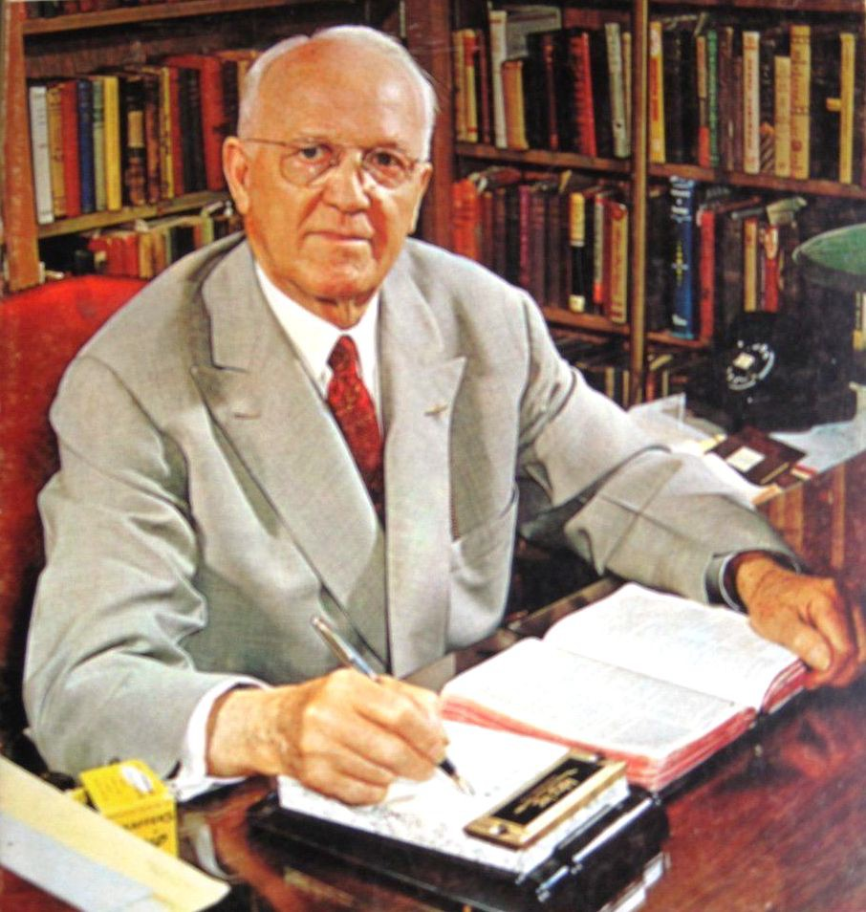 Dr. R.G Lee said, “The Bible is beyond other books as the river is beyond a drop of water, as the sun is beyond the candle, and as the mountain is beyond a grain of sand. It is the fountain in which martyrs have cooled their faces, the pillow upon which the saints of all ages have rested their hearts; it breaks the fetters of the slave, takes the pain out of parting, takes the sting out of death, takes the gloom out of the grave and gives us a hope that is steadfast and sure.” -

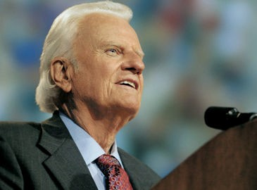Evangelist Billy Graham said, “I know that

many of the things I have said from the Scriptures have offended some, but I cannot afford to tone down the message. As Paul said in 1 Corinthians 9:17, “I have a stewardship entrusted to me,” and that is to preach the pure and simple Gospel in whatever culture I am in.”

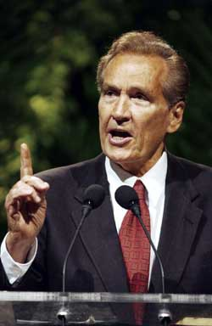 Adrian Rogers said, “How can we know the God of the Bible if we don’t know the Bible of God?”

- They knew that the Gospel is based on the Word of God!

Appl.

    - Gospel preaching must be Biblically Based!
    - The Gospel is rooted in Scripture, thus Gospel sermons must be rooted in Scripture.
    - A sermon is a real sermon only if it’s foundation is the Word of God.
    - The Gospel is powerful!

NAU Romans 1:16 - For I am not ashamed of the gospel, for it is the power of God for salvation to everyone who believes, to the Jew first and also to the Greek.
    - The power of the Gospel is in the Word of God!

NAU Hebrews 4:12 – “For the word of God is living and active and sharper than any two-edged sword, and piercing as far as the division of soul and spirit, of both joints and marrow, and able to judge the thoughts and intentions of the heart.

    - That is why the Apostle Paul told his favorite young

preacher, Timothy, to preach the Word…

NAU 2 Timothy 4:1-5 - I solemnly charge you in the presence of God and of Christ Jesus, who is to judge the living and the dead, and by His appearing and His kingdom: 2 preach the word; be ready in season and out of season; reprove, rebuke, exhort, with great patience and instruction. 3 For the time will come when they will not endure sound doctrine; but wanting to have their ears tickled, they will accumulate for themselves teachers in accordance to their own desires, 4 and will turn away their ears from the truth and will turn aside to myths. 5 But you, be sober in all things, endure hardship, do the work of an evangelist, fulfill your ministry.

      - If a preacher does not base his sermon on the Bible, don’t listen to him!
      - If a preacher rarely refers to the Bible when he preaches, don’t listen to him.
      - If you listen to a preacher, and he just tells stories and cute illustrations, but rarely deals with Scripture, don’t listen to him.
      - There is too much religious speaking that is masquerading as preaching – yet it is merely heretical “ear tickling.”
      - God wants His preachers to preach the Word – to proclaim the Biblical Gospel.

      - Real Gospel Preaching is Scripturally Based.

Gospel Preaching is Christ Centered (22-24; 29-36).

  - Expl.

vv. 22-24 – “Men of Israel, listen to these words: Jesus the Nazarene, a man attested to you by God with miracles and wonders and signs which God performed through Him in your midst, just as you yourselves know—

    - Everyone in and around Jerusalem had heard of Jesus.
    - They had heard of His “miracles, wonders and signs.”
    - Peter began with common ground.
    - Jesus was a well-known figure Whom they knew about.

    - Then Peter lowered the boom on them…

23 this Man, delivered over by the predetermined plan and foreknowledge of God, you nailed to a cross by the hands of godless men and put Him to death.

    - Peter said that it was God’s will for Jesus to die on the cross for the sins of mankind.
    - However, they (the Jews) were the ones guilty of having Jesus nailed to the cross by the hands of the Romans.
    - Even though it was God’s will for the Messiah to suffer as a substitutionary sacrifice for the sins of mankind, in no way did that absolve their guilt for condemning Jesus to death!
    - Though as Jews they were supposedly looking for the Messiah, when He finally came, they had Him crucified!

    - Nevertheless, God gloriously vindicated Him…

24 "But God raised Him up again, putting an end to the agony of death, since it was impossible for Him to be held in its power.”

    - Peter shared the essence of the Gospel – the death and resurrection of Jesus!
    - He spoke of Jesus’ death for sinners to cleanse them from sin.
    - He spoke of Jesus’ bodily resurrection to give them eternal life!

    - He went on to refer to preach more about Jesus’ resurrection when he said in…

29-36 – “Brethren, I may confidently say to you regarding the patriarch David that he both died and was buried, and his

tomb is with us to this day. 30 "And so, because he was a prophet and knew that GOD HAD SWORN TO HIM WITH AN OATH TO SEAT one OF HIS DESCENDANTS ON HIS
THRONE, 31 he looked ahead and spoke of the resurrection of the Christ, that HE WAS NEITHER ABANDONED TO HADES, NOR DID His flesh SUFFER DECAY. 32 "This Jesus God raised up again, to which we are all witnesses. 33
"Therefore having been exalted to the right hand of God, and having received from the Father the promise of the Holy Spirit, He has poured forth this which you both see and hear. 34 "For it was not David who ascended into heaven, but he himself says: 'THE LORD SAID TO MY LORD, "SIT AT MY RIGHT HAND, 35 UNTIL I MAKE YOUR ENEMIES A
FOOTSTOOL FOR YOUR FEET."' 36 "Therefore let all the house of Israel know for certain that God has made Him both Lord and Christ-- this Jesus whom you crucified."
  - Peter said, “You have crucified your LORD!”
  - “You have crucified Your Messiah/Christ!”
  - He is ascended and exalted right now in heaven at the right hand of God the Father.
  - Jesus is exalted and is reigning in heaven in His mediatorial reign while the Father is subjecting to Him all of His enemies, making them “a footstool for His feet.”
  - Peter preaching was Christ Centered.
  - He spoke of the death, resurrection, and ascension of Jesus!

Illus.

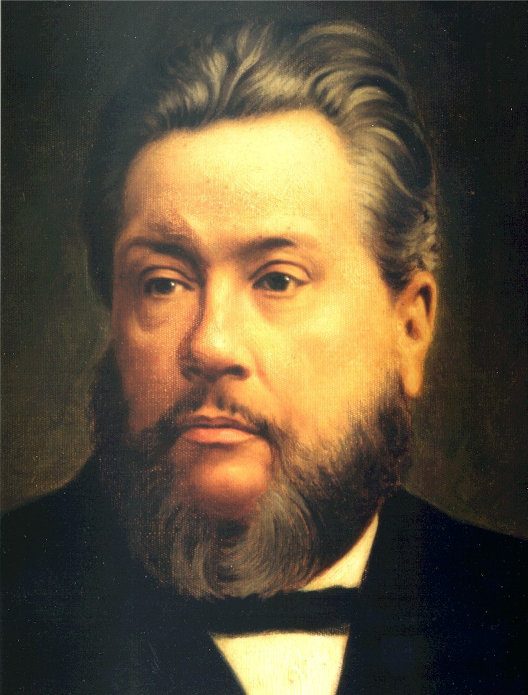C. H. Spurgeon, who preached to over six thousand each week for almost forty years in the 1800s in London said,

Let your sermons be full of Christ, from beginning to end crammed full of the gospel. As for myself, brethren, I cannot preach anything else but Christ and His cross, for I know nothing else, and long ago, like the apostle Paul, I determined not to know anything else save Jesus Christ and Him crucified…. Preach Jesus Christ, brethren, always and everywhere; and every time you preach be sure to have much of Jesus Christ in your sermon…. We preach Jesus Christ to those who want Him, and we also preach Him to those who do not want Him, and we keep on preaching Christ until we make them feel that they do want Him, and cannot do without Him.1

Appl.

- Gospel preaching is Christ Centered.
- Without Jesus, there is no Good News – no Gospel!
- Jesus IS the Gospel!
- The Gospel is ALL about Jesus…

  - Jesus is the Divine/Eternal Son of God
  - Jesus is the Virgin-born Son of God
  - Jesus is the Sinless Son of God
  - Jesus is the Sacrificial Son of God
  - Jesus is the Resurrected Son of God’
  - Jesus is the Ascended/Exalted Son of God
  - Jesus is the Reigning Son of God
  - Jesus is the Heaven-preparing Son of God
  - Jesus is the Interceding Son of God
  - Jesus is the Soon Coming Son of God
  - Jesus is the Saving Son of God

- No wonder the Apostle Paul said…
NAU 1 Corinthians 1:23-24 - But we preach Christ crucified, to Jews a stumbling block and to Gentiles

1 C. H. Spurgeon, The Soul-Winner: How to Lead Sinners to the Saviour (Grand Rapids: Wm. B. Eerdmans Publishing Company, 1963), pp. 106-107.

foolishness, 24 but to those who are the called, both Jews and Greeks, Christ the power of God and the wisdom of God.

NAU 2 Corinthians 4:5 - For we do not preach ourselves but Christ Jesus as Lord, and ourselves as your bond- servants for Jesus' sake.

NAU Ephesians 3:8 - To me, the very least of all saints, this grace was given, to preach to the Gentiles the unfathomable riches of Christ.

- If you go to a church and you rarely if ever hear the name “Jesus,” RUN!!
- If you go to a church and you hear nothing about…

  - Jesus’ death on the cross for mankind’s sins
  - Jesus shedding His blood for the forgiveness of sin
  - Jesus’ bodily resurrection from the dead
  - Jesus’ glorious ascension to heaven
  - Jesus seated upon His thrown, reigning in heaven

- If the preacher talks very little about Jesus, leave immediately!

Gospel Preaching is Christ Centered!

- Evangelistically Persuasive (37-40).

  - Expl.

37 Now when they heard this, they were pierced to the heart,

    - The Jews in Jerusalem that heard Peter’s sermon on the Day of Pentecost fell under conviction by the Holy Spirit.
    - Their “hearts” were pierced.
    - I.e. They were convinced by the Holy Spirit to the very core of their being that they were sinners that needed a Savior.

- They had collaborated with the killing their Messiah!
- His blood was on their hands!
- They were responsible for putting their Lord on a cross!
- How could God ever forgive them?

and said to Peter and the rest of the apostles, "Brethren, what shall we do?"

- “We must do something – but what can forgive such foul, flagrant sin?

38 Peter said to them, "Repent, and each of you be baptized in the name of Jesus Christ for the forgiveness of your sins; and you will receive the gift of the Holy Spirit.

- Peter’s immediate answer? REPENT!
- “Each of you REPENT!”
- “Then, just as John the Baptist required, “Get baptized to show that your repentance is genuine.”
- “When you repent, God will forgive your sins and give you the gift of His Holy Spirit!”
- It was normal for Gentiles that converted to Judaism to be baptized.
- But it was not the norm for native-born Jews to be baptized.
- Peter was saying, “It’s time to get right with God and repent.”
- “It’s also time to turn from Judaism and turn to Christ!”
- If you will repent of your sins and show that you are serious by being baptized, God will give you the same Holy Spirit He has given us!”

39 "For the promise is for you and your children and for all who are far off, as many as the Lord our God will call to Himself."

- This salvation and the ensuing gift of the Holy Spirit is for all people – your children (i.e. future generations) and “all who are far off (Jews who live far away, and even Gentiles).

- Then Luke reminds us that what we have is merely a summary of Peter’s entire sermon…

40 And with many other words he solemnly testified and kept on exhorting them, saying, "Be saved from this perverse generation!"

- Note the urgency and fervency in those final words!

"Be saved from this perverse generation!"
- “Perverse” - σκολιός (Eng. Scoliosis – curviture of the spine) - curved, winding, hence crooked.
- Peter was saying, “Don’t put salvation off! Be saved today!”
- “Turn from this ‘crooked/twisted/warped (scoliosis) generation, and come to Christ – the straight and narrow way!”
- “He will save you! Do it right now!”

- Peter preached the Gospel with Evangelistic Persuasion!

Illus.

- A young preacher once asked Charles Spurgeon why it was that every time Spurgeon preached people were saved, but when he preached nothing happened.
- Spurgeon asked, "You don't expect someone to be saved every time you preach, do you?"
- The young preacher said, "No!"
- "Well," answered the wise preacher, "that's just why you don't see them (get saved)!"

Appl.

- A Gospel preacher is supposed to be evangelistically persuasive!

The Apostle Paul said in NLT 2 Corinthians 5:11 - Because we understand our fearful responsibility to the Lord, we work hard to persuade others. God knows we are sincere, and I hope you know this, too.

- Paul also said in NLT 2 Corinthians 5:20 - So we are Christ's ambassadors; God is making his appeal through us. We speak for Christ when we plead, “Come back toGod!"

- There must be urgency to Gospel Preaching!
- We must share the Gospel with lost people in a manner of fervency and persuasion.

- Heaven’s hands are reaching down to save lost souls
- Hell’s hands are reaching up from the pit for lost souls
- Lost people’s hands are reaching out for the Gospel
- Christ’s hands were nailed to a tree dying for lost souls
- Christians’ hands must be reaching out to win lost souls!

- We must urge and strongly encourage them to be saved!
- When I was a boy at FBC, D’burg, we sang this song…

Oh, do not let the Word depart,
And close thine eyes against the light; Poor sinner, harden not your heart, Be saved, oh, tonight.

  - Refrain:
Oh, why not tonight? Oh, why not tonight? Wilt thou be saved? Then why not tonight?

Tomorrow’s sun may never rise To bless thy long-deluded sight; This is the time, oh, then be wise, Be saved, oh, tonight.

Our Lord in pity lingers still,
And wilt thou thus His love requite? Renounce at once thy stubborn will, Be saved, oh, tonight.

Our blessed Lord refuses none
Who would to Him their souls unite; Believe on Him, the work is done, Be saved, oh, tonight.

    - Gospel Preaching must be Evangelistically Persuasive!

And if Gospel Preaching is… Prophetically Declared, Scripturally Based,

Christ Centered, and
Evangelistically Persuasive, then it will be…

Spiritually Fruitful (41).
  - Expl.

41 So then, those who had received his word were baptized; and that day there were added about three thousand souls.

    - The Lord filled His people with the Holy Spirit.
    - The 120 that had prayed for 10 days went out sharing “the glories of God” with people in the streets of Jerusalem.
    - Peter preached the cross of Jesus and His resurrection, and commanded the people to repent and be baptized so they could receive the Holy Spirit – AND THEY DID!

Illus.

    - During his life, Dr. Rogers led hundreds of people to faith in Christ, but he cherished especially the memory of his first attempt at soul-winning.
    - He was a teenager in North Carolina, attending an evening church worship service.
    - The preacher spoke that evening about sharing Christ with others, and he asked the audience, “How many here will promise to be a soul-winner? Who will promise to win a soul for God?”
    - Adrian earnestly raised his hand.

- He was a new Christian with little training in the Bible, but he sincerely wanted to be a witness for Christ.
- Some time later, Adrian, 16, went back to West Palm Beach where he had been raised.
- One day he was walking to the store wearing only his Levi’s—it was a hot day.
- An old man with white whiskers approached him, needing money.
- The man admitted, “I’ve been an old fool. I live on a pension check. When I got my check this time, I cashed it, and a so-called friend of mine and I got drunk. I spent all my check on whiskey. I’ve been an old fool, and now I don’t have any more money.”
- Adrian said, “Mister, if I had some money, I’d give it to you, but I don’t.”
- But as Adrian started to walk away, the Lord spoke to his heart: “Adrian, speak to him about his soul.”
- Adrian said, “God, I can’t speak to him about his soul; I don’t even have a shirt on!”
- “But Adrian,” the Lord seemed to say, “you promised.”
- “But God, he’s a man and I’m a boy!”
- “Adrian, you promised.”
- As Adrian turned back to the man, his heart was racing. But mustering his courage, he said, “Mister, I don’t have any money to give you, but I believe I have something better than money. Sir, are you a Christian?”
- Tears suddenly streamed from the old fellow’s eyes, and his chin started quivering. “No, son,” he said, “I’m not a Christian.”
- “Sir, would you like to be?”
- The man replied, “More than anything in this world. If only I knew how to be.”
- Then Adrian said, “I wish I had a Bible.”
- “I have one,” replied the old man, and he reached into the lining of his old coat and pulled out a little New Testament. Adrian found John 3:16, read it out loud, and explained the verse as well as he could.
- “Well, what should I do?” said the old man when Adrian was finished.

- “Well, I’m going to pray for you.” And as Adrian began praying for the man, he, too, began crying. When he finished, he said, “Sir, you pray now and ask Him to save you.” So the old man started to pray through his tears and he asked Jesus to come into his heart, forgive his sin, and save his soul. When he finished his prayer, Adrian asked, “Well, did He do it?”
- “I think He did,” said the man.
- Knowing nothing about follow-up, Adrian thanked the man, wished him well, and turned to leave. But the old fellow called him back. “You man, come back here,” he said. “I’m an old man, and I have traveled through almost every state in this country, and you are the first person to ever speak with me about my soul. Thank you, young man, thank you.”
- And that day, Adrian Rogers walked home leaping and dancing and praising God. He had learned the joy of soul- winning.

- God used a teenager who was willing to obey and share!

Appl.

- Christian, if you will faithfully sow the Gospel seed, God will fruitfully give a Gospel harvest!

The Psalmist said in NLT Psalm 126:5-6 - Those who plant in tears will harvest with shouts of joy. 6 They weep as they go to plant their seed, but they sing as they return with the harvest.
- Christian, if you will share the Gospel, God will save people!
- Preacher, if you will preach the Gospel, God will save people!

Gospel Preaching will be Spiritually Fruitful!

Conclusion:

