Allow Me to Illustrate: Why Illustration Is Crucial for Effective Preaching.

HTTPS://YOUTU.BE/JF_X8DSVB_4 (ROPE ILLUSTRATION)

Discussion:

What purpose do illustrations serve?

Do you think preachers may use illustrations for the wrong reasons?

Do you believe that much of preaching is lost in abstraction?



“To illustrate, according to the etymology, is to throw light (or lustre) upon a subject; and hence illustration would strictly include only explanation and ornament. But that which explains may also contain a proof by analogy; or that which adorns a subject may at the same time connect with it pathetic associations. Accordingly, what we call illustrations are used to explain, to prove, to adorn, and to render impressive.” John Broadus, *Treatise,* pg. 213.

Reid vs Howe…(speakers vs listeners)

Howe…(listeners)

Sermons are too complex, have too much analysis, are too formal, have too much theological jargon, use too few illustrations, and too often come to a dead end.



Reid…(speakers)

Preachers use too many complex words, most sermons are dull, most preaching is irrelevant, preaching is not courageous, preaching does not communicate, preaching does not lead to change, and preaching is overemphasized.

Parable-a short allegorical story designed to illustrate or teach some truth, religious principle, or moral lesson. (2 Sam 12:1-15) Allusion-a passing or casual reference; an incidental mention of something, either directly or by implication. (his Achilles’ heel, opening a Pandora’s box, that Judas)

Example-a pattern or model, as of something to be imitated or avoided. (exemplar, standard, paradigm)

Analogy-a similarity between like features of two things, on which a comparison may be based. (heart/pump, life/race, time/thief) Figure of Speech-any expressive use of language, as a metaphor, simile, personification, or antithesis, in which words are used in other than their literal sense. (gentle as a lamb, crying like a baby, the ship groaned)

Illustrations build a bridge between the abstract and the concrete…if people see the Scripture at work in your story they can see how the Scripture can work in their story!

###### 



Definitions…

Illustration- “Illustrations are ‘life-situation’ stories within sermons whose details (whether explicitly told or imaginatively elicited) allow listeners to identify with an experience that elaborates, develops, or explains scriptural principles. Through the details of the story, the listener is able imaginatively to enter an experience in which a sermonic truth can be observed.” (Chapell, pg. 21)



What illustrations are the best?

1. Speaker and Listener share lived experience.

2. Speaker’s learned experience overlaps the Listener’s lived experience.

3. Speaker’s lived experience overlaps Listener’s learned experience.

4. Speaker and listener share learned experience.

5. Speaker and listener share neither lived nor learned experience.



How important is common experience to effective illustration?

Discussion:

Why is it important to understand the structure of powerful stories?

Illustrations should be snapshots not feature films. Appropriate detail is critical!

Phenomenology and detailed experience leads to vivid illustration.



Isolate and Associate: some event, conversation, perception, or relationship is isolated and associated with a principle, concept, or proposition.

Isolate-to set or place apart; detach or separate so as to be alone.

Associate-to connect or bring into relation, as thought, feeling, or memory.

Moving toward illustration…

Description: the importance of bracketed experiences. (slicing the pie)

Reduction: eliminating extraneous detail. What is the essence of the experience?

Interpretation: shifting raw data toward explanation. Meaning is lost if interpretation does not take place!

The Sublime Ordinary: stealing from the world the treasures that others do not notice…

Two things illustrations do…

They improve our relationship with our listeners (they reveal US) and render our preaching more effective (help the listener locate themselves in Scripture).

###### 



Other things that illustrations do…

1. They reveal our perspectives. Example?
2. They reveal our character. Whoa!
3. They increase our ethos. How?
4. They reveal apt (useful) truth. Important?
5. They witness to applicability. How?



Based on studies, the three things that most people remember from a sermon are:

1. The concluding illustration.
2. The opening illustration.
3. The other illustrations.

Then, applications, message idea, interesting concepts, main points, and expositional concept.

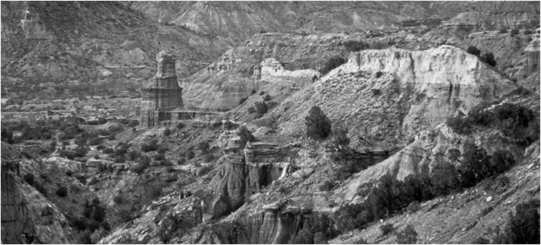

Turn the ear into an eye…



Turn the ear into an eye…

Turn the ear into an eye…



Where can you find illustrations?

Everywhere! Illustrations come from life and should be true, modest, and considerate (don’t violate a confidence).

What events of today could we use as illustrations?



Illustrate This!

I beseech you therefore, brethren, by the mercies of God, that you present your bodies a living sacrifice, holy, acceptable to God, which is your reasonable service.

And do not be conformed to this world,

but be transformed by the renewing of your mind, that you may prove what is that good and acceptable and perfect will of God.

1. Illustrations should illustrate a truth.
2. Illustrations should be understandable.
3. Some illustrations are more effective.
4. Illustrations should be convincing.
5. Illustrations should be appropriate to the theme and the audience.
6. Illustrations should be enthusiastic!

###### 



THE END

My brethren, count it all joy when you fall into various trials, knowing that the testing of your faith produces patience.

But let patience have its perfect work, that you may be perfect and complete, lacking nothing.

If any of you lacks wisdom, let him ask of God, who gives to all liberally and without reproach, and it will be given to him.

But let him ask in faith, with no doubting, for he who doubts is like a wave of the sea driven and tossed by the wind. For let not that man suppose that he will receive anything from the Lord; he is a double-minded man, unstable in all his ways.

(Jam 1:2-8 NKJ)



Illustrate This!

Therefore, brethren, having boldness to enter the Holiest by the blood of Jesus, by a new and living way which He consecrated for us, through the veil, that is, His flesh, and having a High Priest over the house of God,

(let us draw near) with a true heart in full assurance of faith, having our hearts sprinkled from an evil conscience and our bodies washed with pure water.

(Let us hold fast) the confession of our hope without wavering, for He who promised is faithful.

(And let us consider one another) in order to stir up love and good works, not forsaking the assembling of ourselves together, as is the manner of some, but exhorting one another, and so much the more as you see the Day approaching.

(Heb 10:19-25 NKJ)